Silent Auction for the benefit of Stripers Forever
Game Fish Initiatives

2012 Auction winners
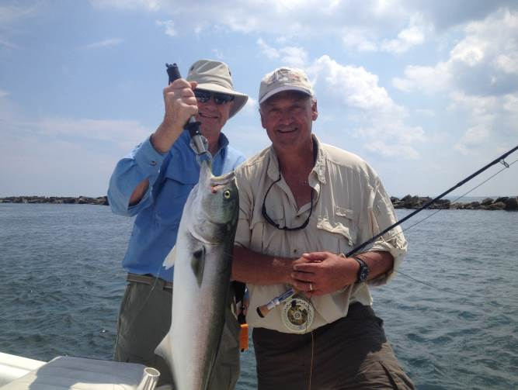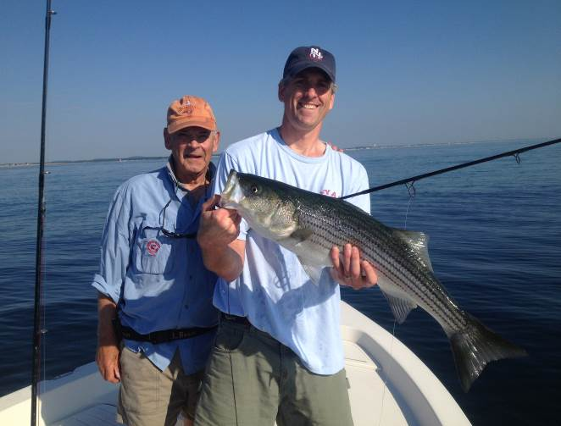
July 24, 2012 July 12, 2012

Striped Bass-Bluefish Charter
with
Joppa Charters
Capt. Dave Rimmer
Merrimack River and Plum Island, MA

Join seasoned fisherman and guide Dave Rimmer for fly and light tackle fishing aboard his 22-foot Pathfinder bayboat on the legendary and picturesque waters of the Merrimack River and Plum Island area in northeastern Massachusetts. Fish fast moving river currents with varied structure, steep cut marsh banks, mud and sand flats as well as open ocean with rips and sand bars along the outer beaches. Target striped bass of all sizes throughout the season and bluefish mid to late season. All gear available if needed or bring your own. Trip departure location will either be Merrimack River or Parker River.
Go to www.joppacharters.com for full details.
Duration 6 hours starting around first light.
1-2 anglers. Trip valid through 12/31/13.

The current bid is for this trip is $650.
Bidding ends 9:00 pm Wed. 4/24/2013.
*bids are not automatically updated, and there may be a lag time between bidding and posting to the website. There may be a higher bid in than is reflected here.

To bid send SF an e-mail stripers@whatifnet.com with your bid. You will be notified right away if your bid is not the high bid, and what the high bid currently is. The winning bid can pay by credit card or send a check to SF.

