Silent Auction to Benefit Stripers Forever
Sankaty Head Charters w/Capt. Hal Herrick
Fish the famous big bass waters around Nantucket Island from Captain Hal Herrick’s 23’ Jones Brothers during the prime June or early July season. The duration of the trip is four and one half hours, and a maximum of three anglers can be accommodated.

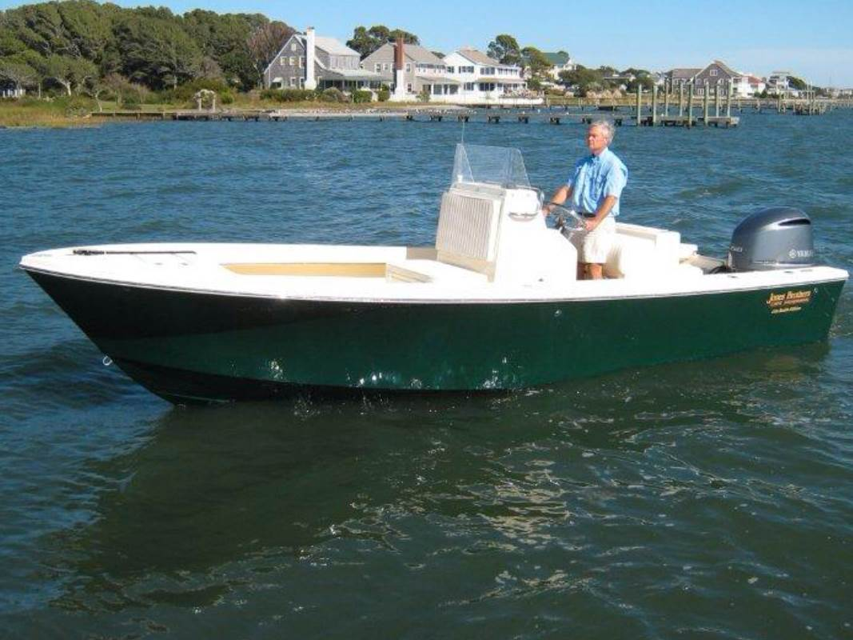

Fly or light tackle, top quality gear provided. Go to the website for full information on Captain Hal. Check out the great fishing map of Nantucket on the site.

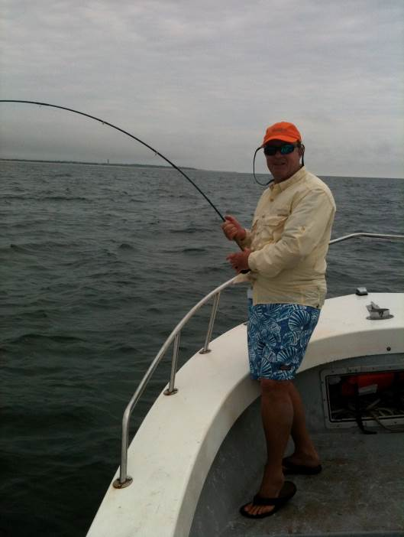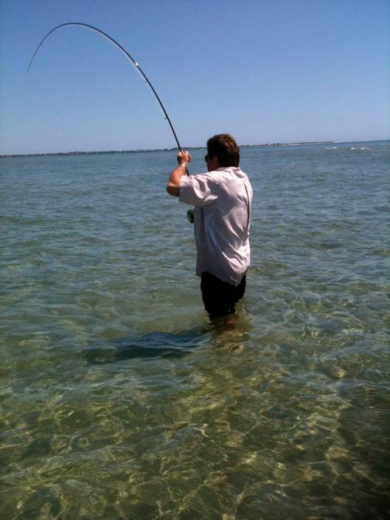

A copy of fellow Nantucket Captain Matt Reinemo’s
new book Fishing Nantucket is included to get the juices flowing!
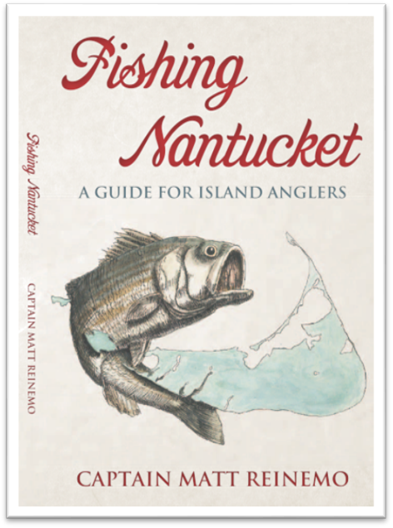

The current bid is $500 for the trip and book
Bidding ends 9:00 pm Wed. 4/24/2013.
*bids are not automatically updated, and there may be a lag time between bidding and posting to the website. There may be a higher bid in than is reflected here.

To bid send SF an e-mail stripers@whatifnet.com with your bid. You will be notified right away if your bid is not the high bid, and what the high bid currently is. The winning bidder can pay by PayPal or check to SF. Note – all new bids must be at least $20 greater than the previous bid.

